RAHA INTERNATIONAL SCHOOL

GARDENS CAMPUS

POLICIES

Policy title | School Uniform Policy
Policy number | GC_POL_SU_017
Policy Version | 3
Effective date | April 2022
Scheduled review date | June 2026

Prepared by | Name
Head of Admissions | Estée Caplen

Approving Committee | Name | Signature
Vice Principal | Carol Michelle Pratt

Table of Contents
Uniform Policy 3
Early Years (EY1 – EY2) 3
Primary Students (Grades 1-5) 5
Acceptable Footwear (EY1- Grade 5) 6
MYP Students (Grades 6-10) 7
DP Students (Grades 11-12) 8
Revision Log 10

Uniform Policy

The school uniform is to be worn during each school day unless special activity days are announced. Students are expected to wear the uniform to and from school. We encourage our students to take pride in their uniforms as a reflection of their pride in the School. Clothes worn underneath the shirts must be plain white or natural-coloured.

All school uniform must be purchased from Magrudy’s at Forsan Mall or the Secondhand Uniform Shop (SHUS) located on campus. There will be no exceptions to this rule. Students should be well groomed, with a neat appearance and a well-maintained school uniform.

Early Years (EY1 – EY2)
Standard School Uniform – to be purchased through Magrudy’s
- Early Years students will wear green Raha polo shirts. Raha shorts (boys) and skorts (girls) for Early Years students are grey with red piping.
- Early Years students may wear the grey trousers (for religious reasons or during cooler months).
- Girls may wear leggings under skorts. These should be plain and compliment the uniform colours (white, dark grey or black).
- Shoes need to be plain, solid black. They must be shoes, not sandals and should be closed toe (see examples under Primary section).
- Socks must be solid black or white.
- Undergarments should not be visible.
- Standard school uniform must be worn at all times except on PE days. On PE days Primary students should wear their PE uniform.
Hoodies - to be purchased through Magrudy’s
- Only official school hoodies may be worn.
- Students may wear existing Raha jumpers/hoodies purchased through Magrudy’s, the Parent Team or Raha Raptors hoodies.
PE Uniform - to be purchased through Magrudy’s
- Standard PE uniform is the PE shirt and shorts or tracksuit bottoms purchased through Magrudy’s.
- Footwear for PE need to be closed-toe runners/sneakers with socks.
- Early Years students should wear their PE uniform on days that they have PE.

Hair/Headwear and Jewellery
- Hair should be neat, of a natural colour and not of a distracting nature to the student or others.
- Jewellery should be minimal and plain (no dangling earrings).
- Items such as shaylas, belts and hair clips should be plain and compliment the uniform colours (white, dark grey or black)
- Headwear must be removed inside the buildings, excluding shaylas.
- Early Years students are not permitted to wear makeup.
Swimming gear
- Girls’ swimsuit must be one piece only.
- Swim-shorts with a waist drawstring for boys.
- A poncho style towel must be brought to school on swimming days to assist students to dry off and get changed with modesty.
- Students must bring their own towels, swim caps, and goggles for swimming.
- School issue swimsuits are not compulsory.
- See below for guidance on swimwear and footwear on swimming days:
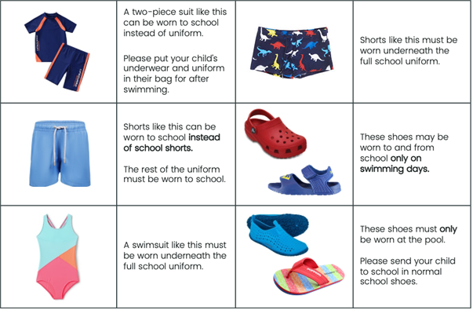

Footwear
- See footwear guidelines under Primary Uniform section

Primary Students (Grades 1-5)
Standard School Uniform – to be purchased through Magrudy’s
- Primary students will wear white Raha polo shirts. Raha shorts (boys) and skorts (girls) for Primary students are grey with red piping.
- Primary students may wear Raha grey trousers (for religious reasons or during cooler months).
- Girls may wear leggings under skorts. These should be plain and complement the uniform colours (white, dark grey or black).
- Shoes need to be plain, solid black. They must be shoes, not sandals and should be closed toe (see examples below).
- Socks must be solid black or white.
- Undergarments should not be visible.
- Standard school uniform must be worn at all times except on PE days. On PE days Primary students should wear their PE uniform.
Hoodies - to be purchased through Magrudy’s
- Only official school hoodies may be worn.
- Students may wear existing Raha jumpers/hoodies purchased through Magrudy’s, the Parent Team or Raha Raptors hoodies.
PE Uniform - to be purchased through Magrudy’s
- Standard PE uniform is the PE shirt and shorts or tracksuit bottoms purchased through Magrudys.
- Footwear for PE need to be closed-toe runners/sneakers with socks.
- Primary students should wear their PE uniform on days that they have PE.
Hair/Headwear and Jewellery
- Hair should be neat, of a natural colour and not of a distracting nature to the student or others.
- Jewellery should be minimal and plain (no dangling earrings).
- Items such as shaylas, belts and hair clips should be plain and compliment the uniform colours (white, dark grey or black)
- Headwear must be removed inside the buildings, excluding shaylas.
- Primary students are not permitted to wear makeup.
Swimming gear
- Girls’ swimsuit must be one piece only.
- Swim-shorts with a waist drawstring for boys.
- A poncho style towel must be brought to school on swimming days to assist students to dry off and get changed with modesty.
- Students must bring their own towels, swim caps, and goggles for swimming.
- School issue swimsuits are not compulsory.

Final decisions on what constitutes the proper uniform are at the discretion of the Head of School.

Acceptable Footwear (EY1- Grade 5)
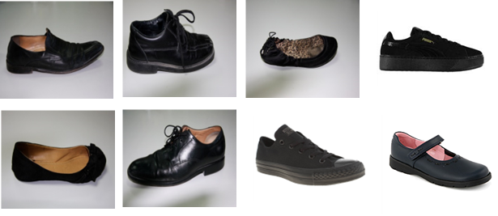

Unacceptable Footwear (EY1- Grade 5)
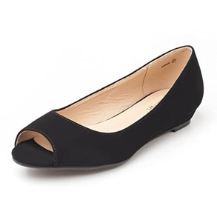
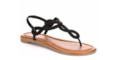
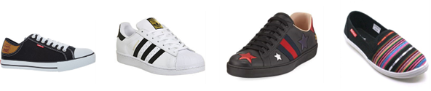

MYP Students (Grades 6-10)
Standard School Uniform – to be purchased through Magrudy’s
- MYP Raha shirts are white with dark green bands.
- MYP Raha trousers are charcoal grey with red piping.
- Uniform shirts are to be worn at all times, even under hoodies.
- All buttons on shirts need to be done up appropriately.
- Socks must be solid black or white.
- Undergarments should not be visible.
- Standard school uniform must be worn at all times.
Hoodies - to be purchased through Magrudy’s
- Only official school hoodies may be worn.
- Students may wear existing Raha jumpers/hoodies purchased through Magrudy’s, the Parent Team or Raha Raptors hoodies.
PE Uniform - to be purchased through Magrudy’s
- Standard PE uniform is the PE shirt and shorts or tracksuit bottoms.
- Plain black, white or grey long sleeves and/or leggings may be worn under the regular PE uniform.
- Sports appropriate footwear must be worn.
- MYP students will change into their PE kits on PE days.
Hair/Headwear and Jewellery
- Hair should be neat, of a natural colour and not of a distracting nature to the student or others.
- Jewellery should be minimal and plain (no dangling earrings).
- Items such as shaylas, belts and hair clips should be plain and compliment the uniform colours (white, dark grey or black)
- Headwear must be removed inside the buildings, excluding shaylas.
- Make-up is limited to natural foundation, eyeliner, mascara and natural/clear lip colour.
Swimming gear
- Girls’ swimsuit must be one piece only.
- Swim-shorts with a waist drawstring for boys.
- Students must bring their own towels, swim caps, and goggles for swimming.
- School issue swimsuits are not compulsory.
Footwear
- MYP students may wear black, white or any combination of black and white shoes.
- Open-toe shoes, shoes without a full back, and “Crocs” are not considered acceptable footwear.

Acceptable | Not Acceptable
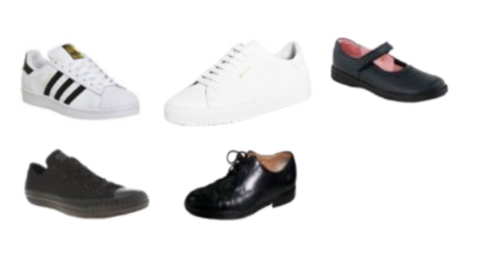 | 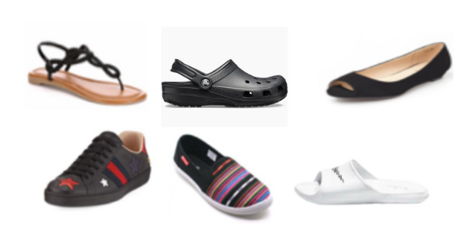

Final decisions on what constitutes the proper uniform are at the discretion of the Head of School.

DP Students (Grades 11-12)

Standard School Uniform – to be purchased through Magrudy’s
- DP Raha shirts are white with black bands.
- Trousers for DP students must be black.
- Students do not have to purchase trousers through Magrudy’s.
- If not purchased through Magrudy’s, trousers must adhere to the following guidelines:
- Smart or business trousers which should not be shorter than ankle height.
- Leggings, sweatpants, flared leggings, jeans/coloured jeans and oversized trousers are considered inappropriate and may not be worn.
- Uniform shirts are to be worn at all times, even under hoodies.
- All buttons on shirts need to be done up appropriately.
- Socks must be solid black or white.
- Undergarments should not be visible.
- Standard school uniform must be worn at all times.
Hoodies – to be purchased through Magrudy’s
- DP students may wear solid black jumpers/ zip-up jackets with no logos.
- DP Grade 12 students may wear their class hoodies/ jumpers.
PE Uniform – to be purchased through Magrudy’s
- Standard PE uniform is the PE shirt and shorts or tracksuit bottoms.
- Plain black, white or grey long sleeves and/or leggings may be worn under the regular PE uniform.
- Sports appropriate footwear must be worn.
Hair/Headwear and Jewellery
- Hair should be neat, of a natural colour and not of a distracting nature to the student or others.
- Jewellery should be minimal and plain (no dangling earrings).
- Items such as shaylas, belts and hair clips should be plain and compliment the uniform colours (white, dark grey or black)
- Headwear must be removed inside the buildings, excluding shaylas.
- Make-up is permitted to be worn by MYP/DP girls but is limited to foundation, mascara and clear lip gloss only.
Swimming gear
- Girls’ swimsuit must be one piece only.
- Swim-shorts with a waist drawstring for boys.
- Students must bring their own towels, swim caps, and goggles for swimming.
- School issue swimsuits are not compulsory.
Footwear
- DP students may wear black, white or any combination of black and white shoes.
- Open-toe shoes, shoes without a full back, and “Crocs” are not considered acceptable footwear.

Acceptable | Not Acceptable

Final decisions on what constitutes the proper uniform are at the discretion of the Head of School.

Dress Down or Theme Days (MYP and DP Students) including “Fitness Fridays”

Dress-down days are days when students are not required to wear their school uniform, while theme days involve students dressing according to a specific theme. These days can offer a break from the regular school uniform, provide opportunities for creativity, and can be used to promote community in a positive way.

Theme days are events where students dress according to a specific theme, like a particular decade, a profession, colour, or character. These days can be fun and educational, promoting creativity, social interaction, and support a good cause.

In the event that we offer designated dress-down or theme days where students can deviate from the regular school uniform, students are expected to adhere to the following guidelines.

Specific Guidelines

These rules may vary depending on the theme and the specific event (such as “Fitness Friday”).
Some common examples include:
  - Tight clothes, such as leggings, tight shirts, or bodysuits are not permitted
  - Clothing with thin or spaghetti straps, exposed midriffs, or offensive logos/expressions are not permitted
  - Tank tops or sleeveless shirts are not permitted for any students
  - Shorts should reach the knee, for both female and male students, with the exception of Raha issued sports kit (PHE or Raha Raptors)

Cultural Sensitivity

While not required to wear the full school uniform, students should still be dressed appropriately and respectfully, avoiding offensive or inappropriate attire. Students should be mindful of the laws, customs, and values of the UAE when choosing their clothing.

Violations of the uniform policy, including on dress-down or theme days, may result in consequences such as removal from lessons, removal from the day’s events, and/or loss of dress down privilege in the future.

Revision Log

Date | Changes | Reviewed By
September 2019 | Minor updates to policy | Estée Caplen
June 2020 | Updated policy to include new and old uniform guidelines | Estée Caplen  Kathryn Simms
April 2022 | Updated new PE and Hoodie supplier | Estée Caplen
April 2024 | Full Policy Review | Estée Caplen
August 2025 | Minor Updates and addition of Dress-Down Day rules | Estée Caplen , Rachel Smith, Penny Thompson, Emily Merton

