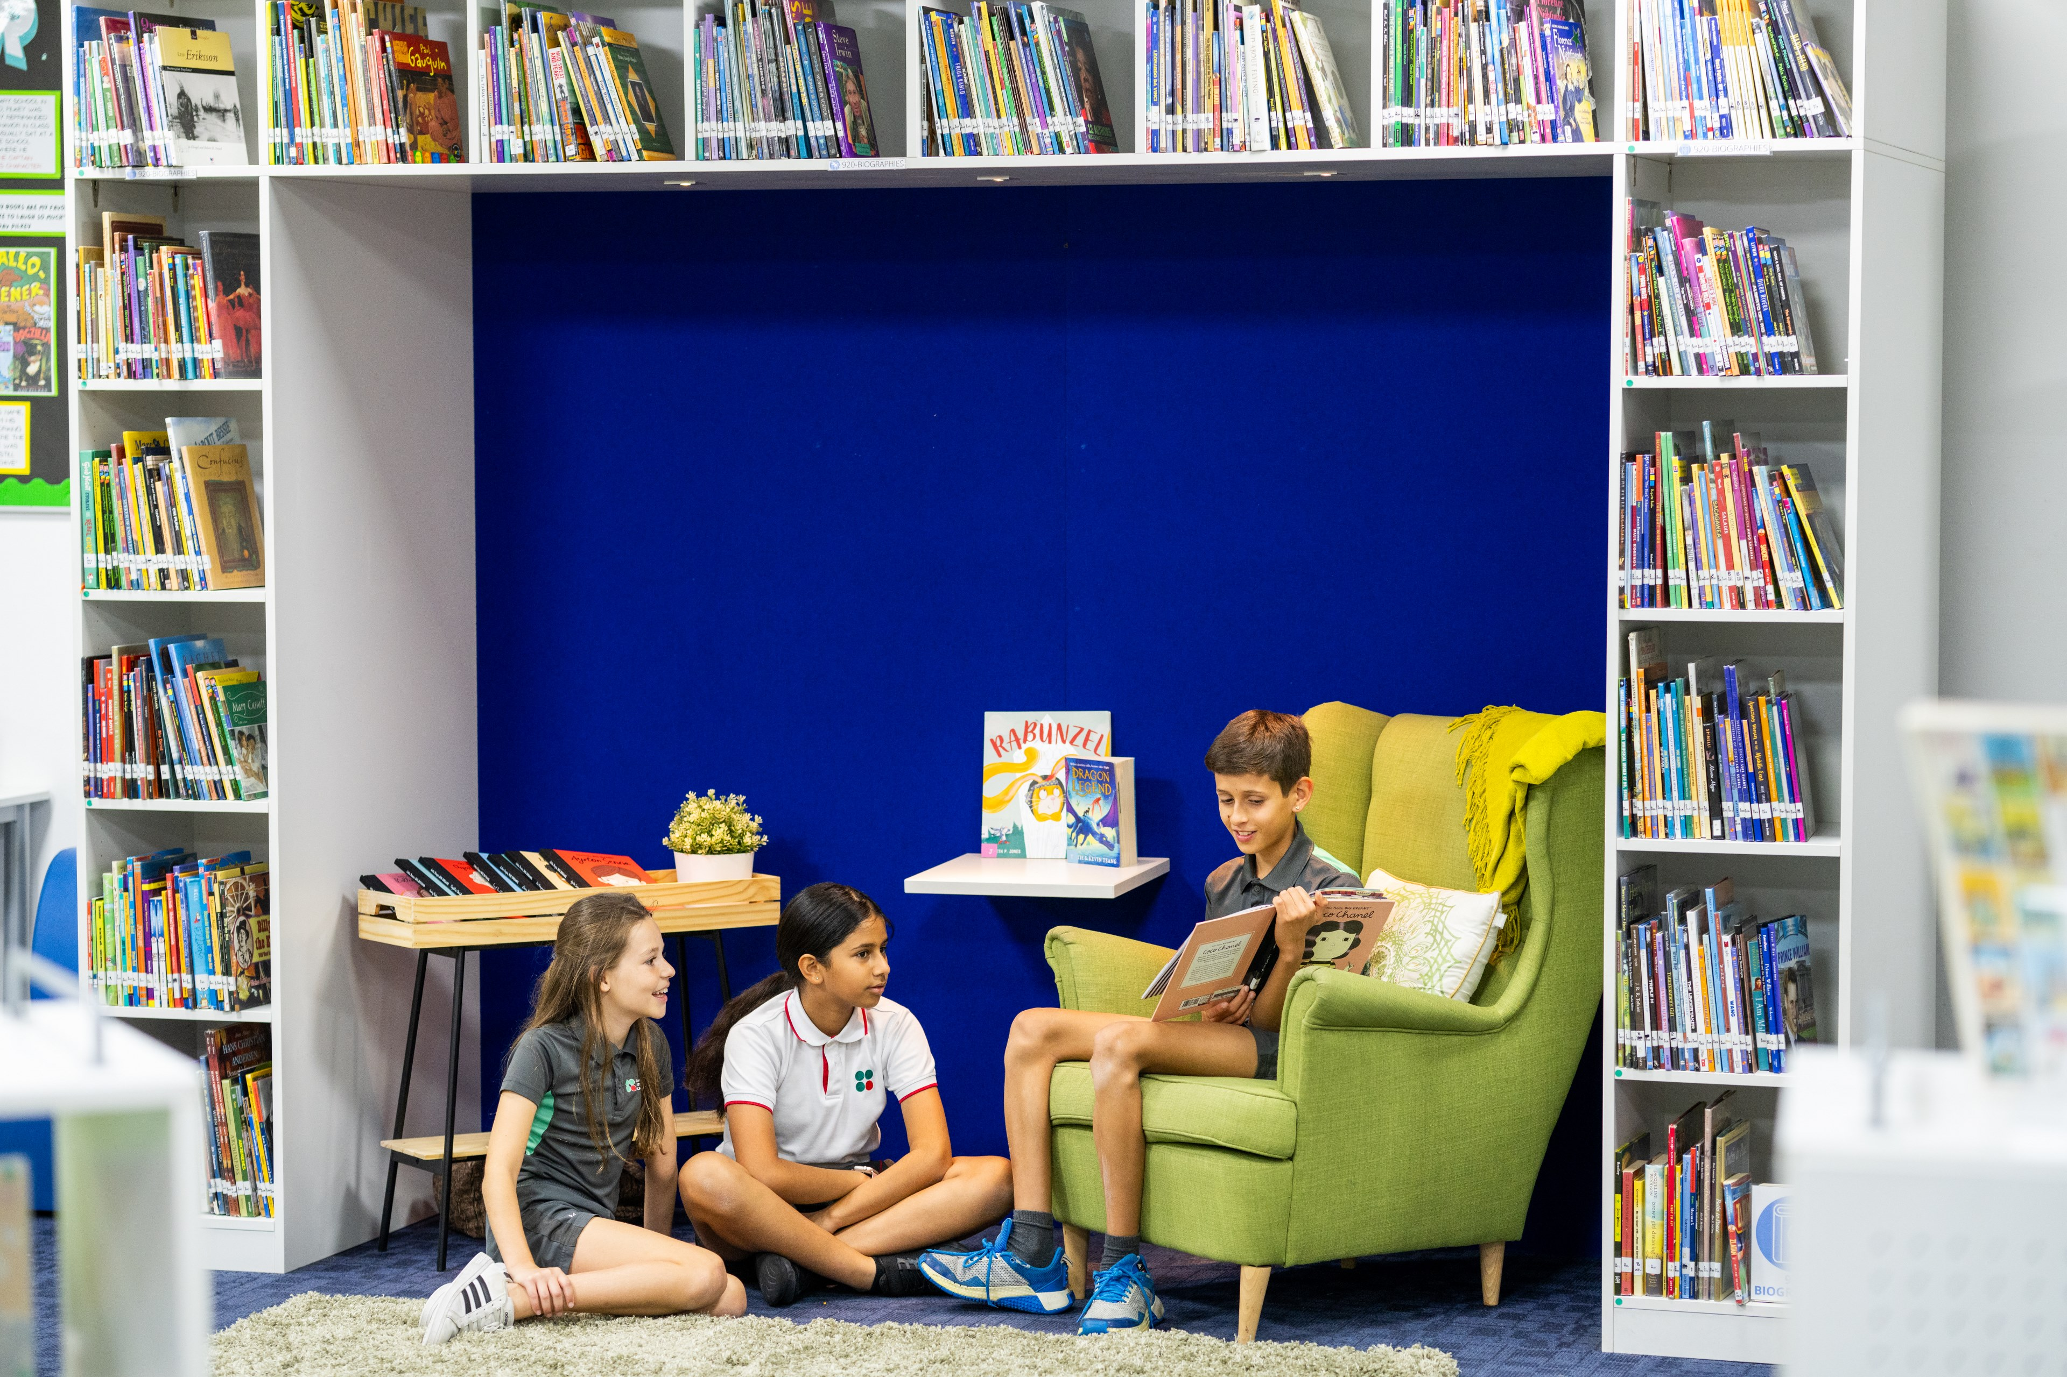

Raha Reminders
Issue 28

Key Dates
- 6-7 May: G8 Parkour Trip
- 6-10 May: G3-9 PT Assessments
- 6-17 May: G2-5 ABT Assessments in MoE subjects
- 7 May: G10 AB & EF F45 Fitness Trip
- 8 May: Parent Assembly with Michael (8:00-9:00am, Black Box)
- 8-9 May: G2 Manarat Al Saadiyat Trip
- 9 May: G6 Abu Dhabi National Theatre Trip
- 21 May: Secondary Sports Award Evening (5:30-7:00pm)
- 23 May: G5 PYP Exhibition (5:00pm)
- 28 May: Primary Sports Awards Evening (5:30-7:00pm)
- 29 May: Primary Music Recital (5:00pm @ KCC)
- 30 May: G1-5 Student-Led Conferences

Principal's Message
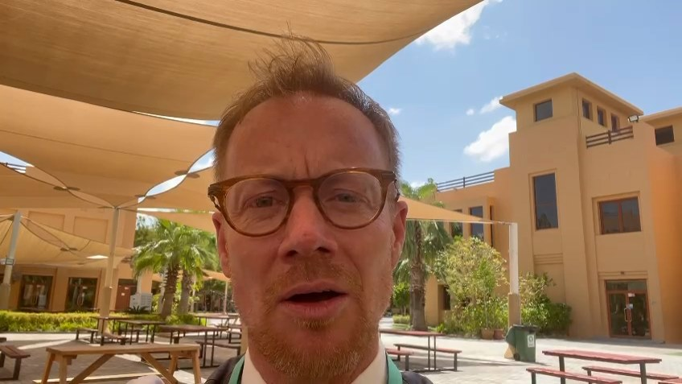
https://sway.cloud.microsoft/rQXxyDO7B4YUxZCU#content=y0mtEUIGUJxQxy

Parent Team Newsletter
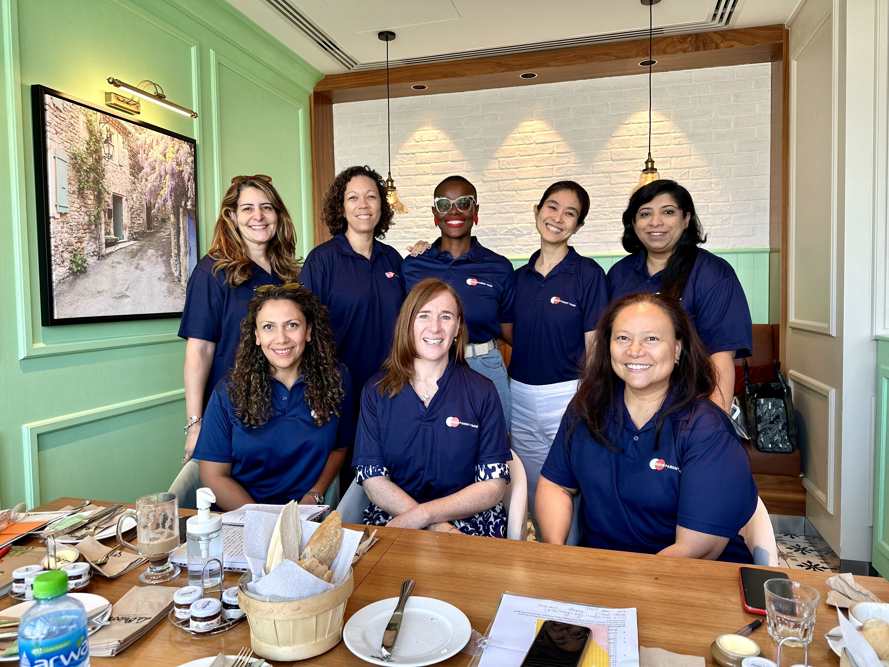

General
Thank You Food Nation
Amid a very wet 2 May 2024, we were warmed by the generosity of Food Nation. Their thoughtful food donation for our essential staff brightened our day and nourished our spirits. We extend our heartfelt gratitude for their support during these challenging times. It's gestures like these that remind us of the strength of our community and the power of kindness. Thank you, Food Nation, for your unwavering support.

Food Nation:
- Themed Lunch Menu - Summer Food Festival

Yearbook Sale Extended
Secure your copy of the 2023/24 Raha Yearbook, currently available for purchase. The first 100 copies are sold out! We will extend the sale to 50 more copies. Please write your name on the waiting list at Front Desk if you wish to enter the second batch. The cost is 160 AED (cash only).

Dressing Respectfully
Now that the weather is officially warming up for summer, this is a kind reminder to our campus visitors (parents and friends) to show consideration for the culture and customs of the UAE and dress respectfully while visiting school. ADEK Compliance requires that campus visitors wear no revealing clothing. Still, as an IB World School, we prefer to focus on how we can show the Learner Profile attribute of Caring by ensuring our attire is appropriate.
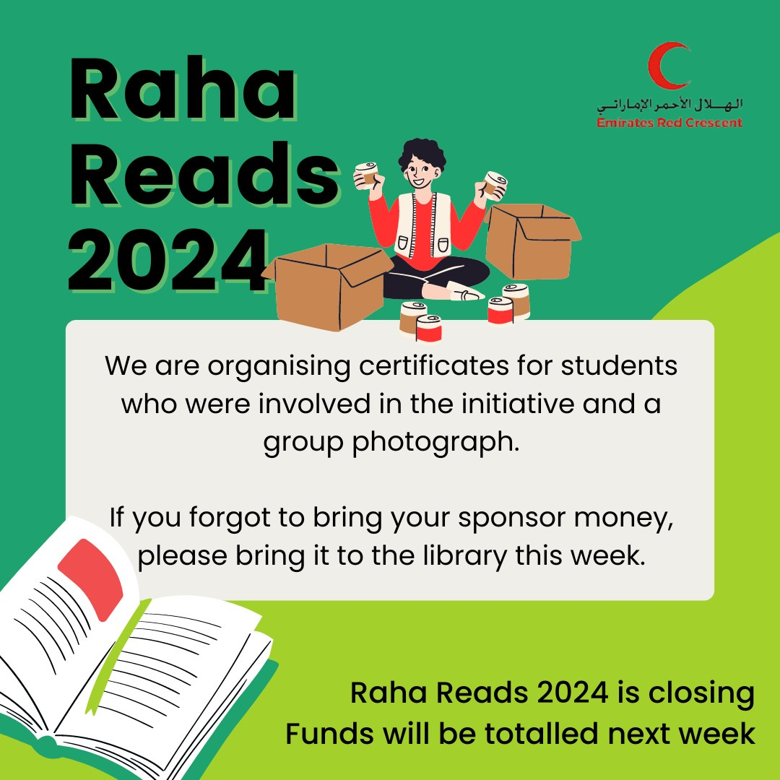

Early Years
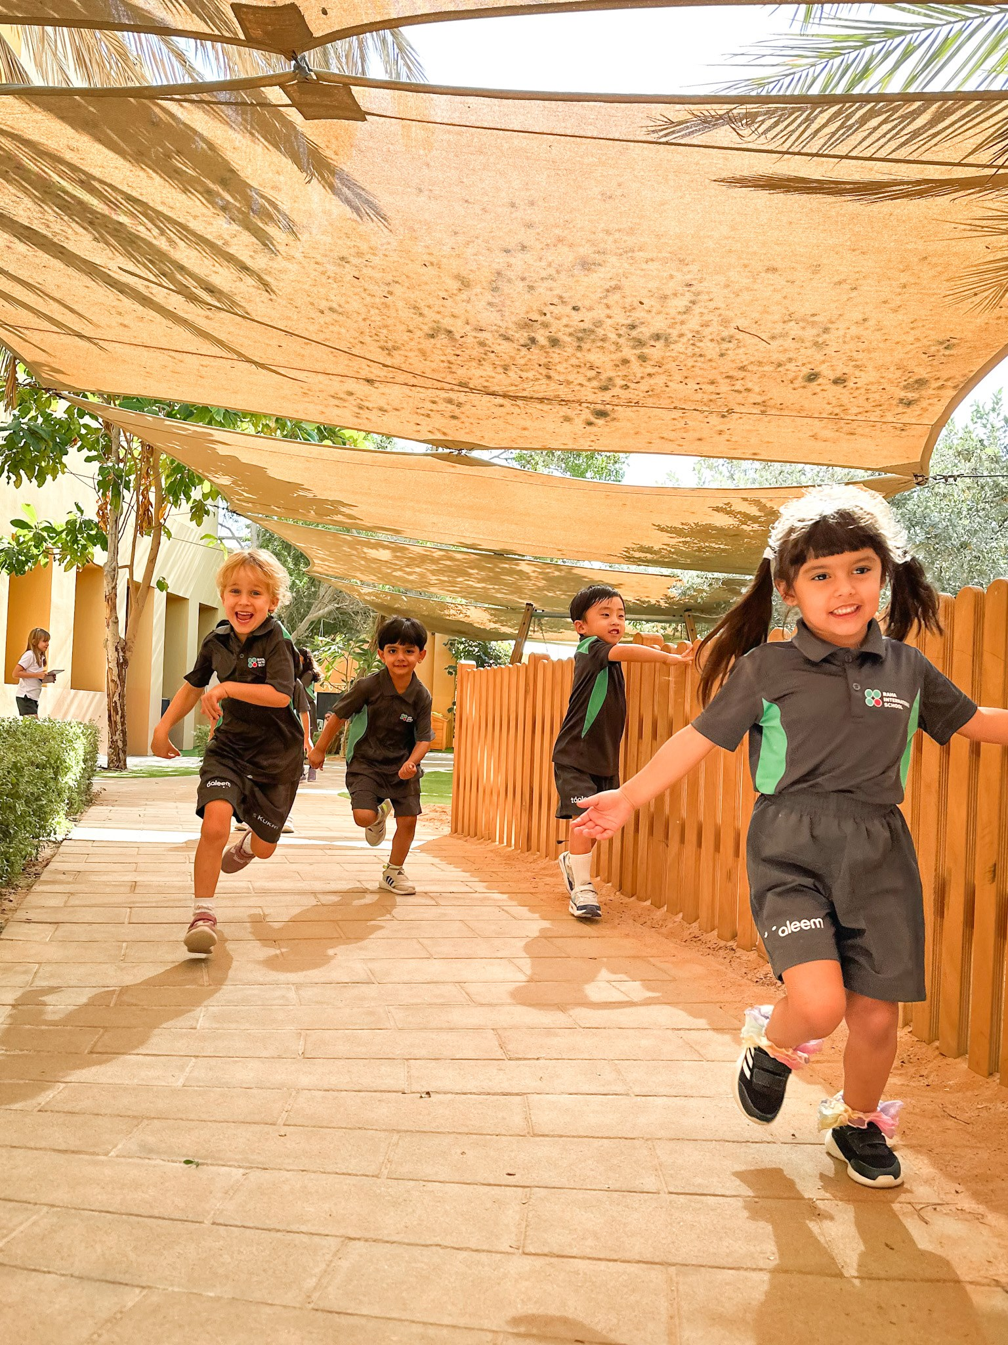
- 20 May: EY Swimming begins
- 22-23 May: EY1-EY2 Gruffalo's child theatre trip
- 3 June, 10 June, 24 June, 1 July: Monday Madness Days!
- 27 June: EY2 Graduation Ceremony

Sun Safety Reminder
As many of you have noticed an increase in the temperature this week, it is imperative that we continue to take sun safety very seriously. As such, this is a reminder of our ‘No hat, No play’ policy. We would also recommend applying sun cream before coming to school, and mosquito repellant.

EY Swimming
Swimming will resume for our EY students on 20 May. Your child will require their swimming kit for both PE lessons. Please refer to the email from Ms Louise.

EY & Primary Upcoming Monday Madness Days!
This is a heads-up to our parents: throughout June and July, we will be inviting students to dress up for Monday Madness across EY and Primary.
- 3 June: Favorite color day
- 10 June: Pajama day
- 24 June: Crazy hair day
- 1 July: Dress like a teacher
EY1-G5 Student Led Conference Day
Save the Date! May 30th is EY1-G5 Student Led Conference Day.
Normal school hours will not apply for EY and Primary students, so please plan accordingly. Students only attend school with their parents during their booked appointment times. Appointments will be open for booking in the coming weeks.

Primary
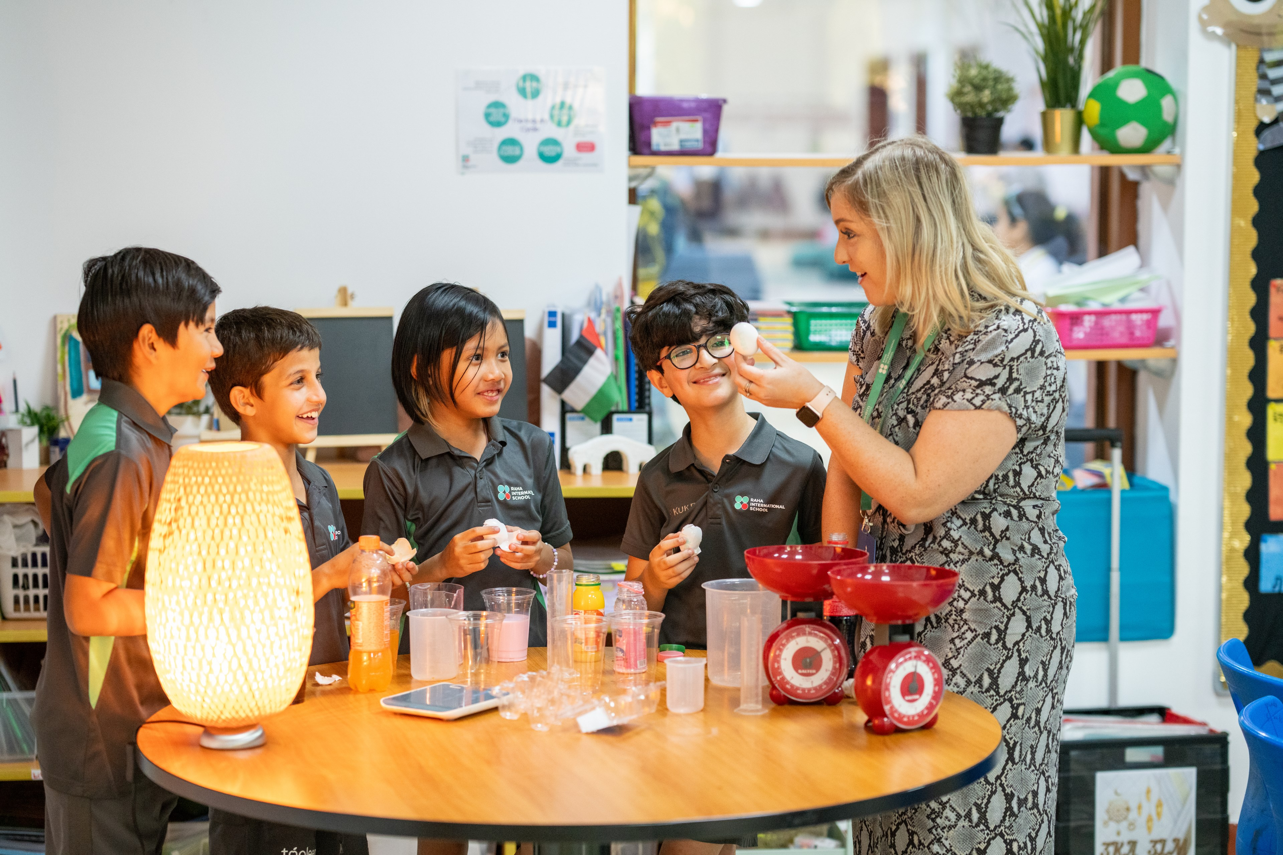

- 28 May: Primary Sports Awards Evening
- 29 May: Primary Music Recital (5:00pm @ KCC)
- 30 May: Student led conferences
Sun Safety Reminder
As many of you have noticed an increase in the temperature this week, it is imperative that we continue to take sun safety very seriously. As such, a reminder of our ‘No hat, No play’ policy. We would also recommend applying sun cream before coming to school, and mosquito repellant.

EY & Primary Upcoming Monday Madness Days!
This is a heads-up to our parents: throughout June and July, we will be inviting students to dress up for Monday Madness across EY and Primary.
- 3 June: Favorite color day
- 10 June: Pajama day
- 24 June: Crazy hair day
- 1 July: Dress like a teacher

Primary Sports Awards Evening
All students who played on a Raha Raptors team this year are invited, along with their parents, to the Primary Sports Awards Presentation. All the teams will be recognized in the Auditorium from 5:30-6:30 pm on May 28th, then you are welcome to join the coaches in the canteen for a treat and refreshments with your fellow Raha Raptors athletes!

Primary Music Recital
Young musicians in G1-5 are invited to sign up HERE for the Primary Music Recital, which will be held in the KCC Black Box on Wednesday, 29th May, at 5pm. Students must be able to play a piece confidently all the way through on their chosen instrument. The deadline for applying is Friday 17 May at 12:00pm. Please note, depending on numbers, not all students may be accepted, but we also have the summer concert coming up, so we may ask some pupils to perform at that instead.

G2-5 ABT Assessments in MoE Subjects
تعتبر هذه التقييمات مقياسًا خارجيًّا لمستوى تقدم الطلاب من شهر سبتمبر/أكتوبر إلى شهر مايو والتي ستساعدنا نتائجها على تقييم تقدم طلابنا الأكاديمي. تقديرنا الكبير لمشاركة أبنائنا الطلاب في هذه التقييمات ولجهودكم المبذولة معنا خلال العام الدراسي.
سيقوم المعلمون بتدريب الطلاب استعدادا لهذه التقييمات ونشجع الطلاب الأعزاء على التدرب في المنزل أيضًا باستخدام الرابط التالي اختبارات الإي بي تي التجريبية مع خالص الدعوات لهم بالتوفيق والسداد
These assessments is an external measure of students' progress from September/October to May, and the results will help us evaluate our students' academic progress. We greatly appreciate the participation of our students in these assessments and your efforts throughout the academic year.
Teachers will be preparing students for these assessments, and we encourage students to also practice at home using the following link: https://abt-assessments.Com/ (Demo). We wish them

EY1-G5 Student Led Conference Day
Save the Date! May 30th is EY1-G5 Student Led Conference Day.
Normal school hours will not apply for EY and Primary students, so please plan accordingly. Students only attend school with their parents during their booked appointment times. Appointments will be available in the coming weeks.

Secondary
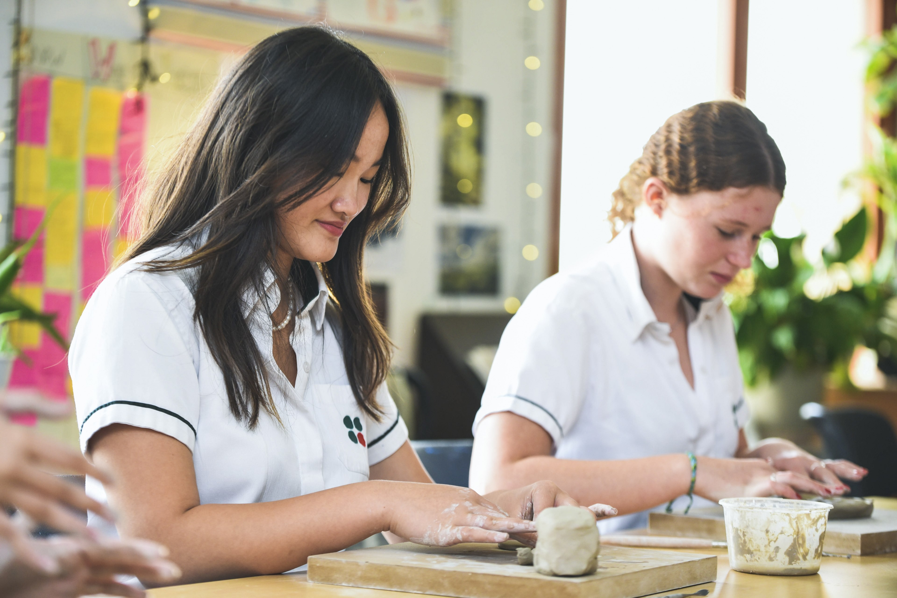
Secondary Sports Awards Evening
All students that played on a Raha Raptors team this year are invited, along with their parents, to the Sports Awards Presentation. All the teams will be recognized in the the Auditorium from 5:30-6:30pm, then you are welcome to join the coaches in the canteen for a treat and refreshments with your fellow Raha Raptors athletes!
Grade 11 Extended Essay Support - SRC
The library aims to serve all our students – G11 students are invited to work on their Extended Essays after school on Mondays: a 15-minute information session and a 45-minute research and writing time.
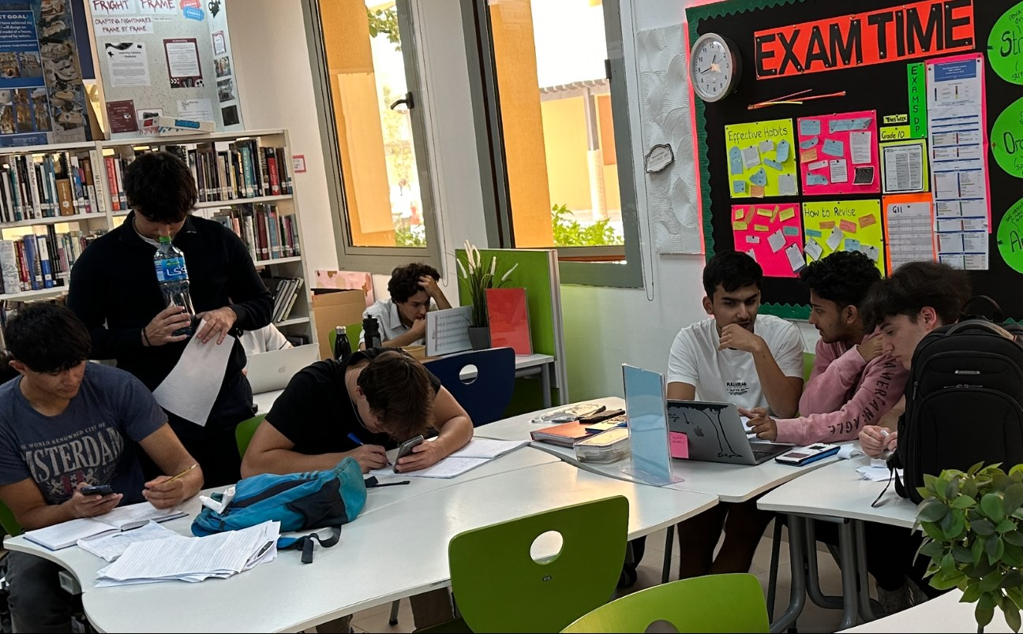

Evening of the Arts

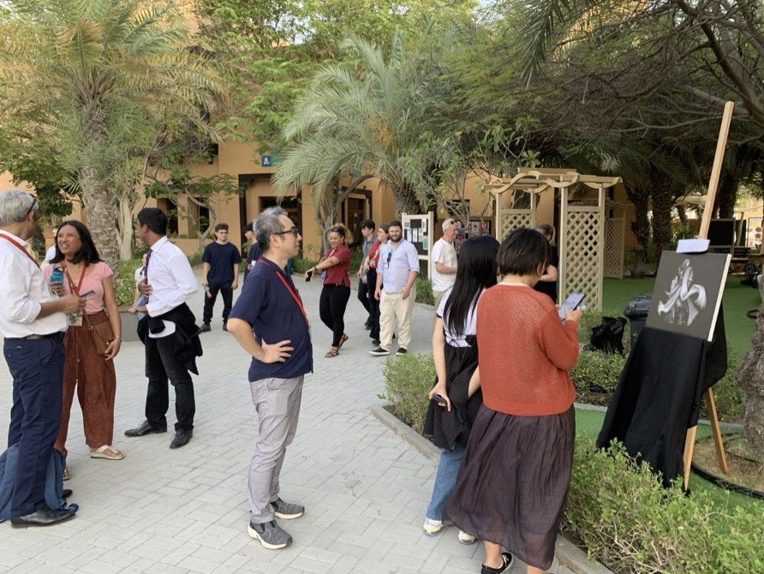
1 - Parents gathered visiting the gardens
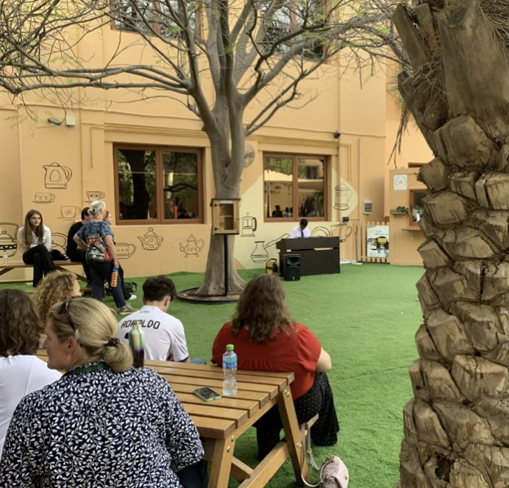
2 - Listening to a piano piece
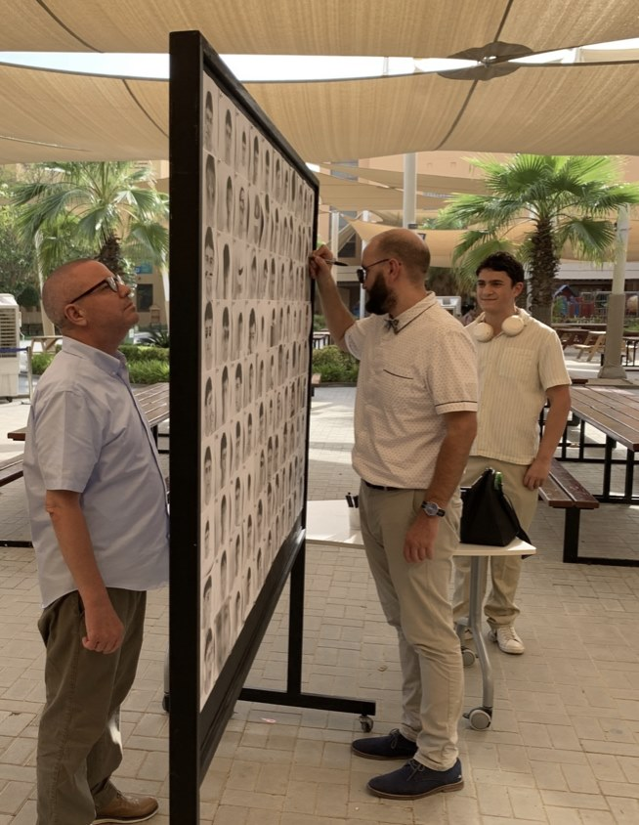
3 - Drawing on a students immersive pice
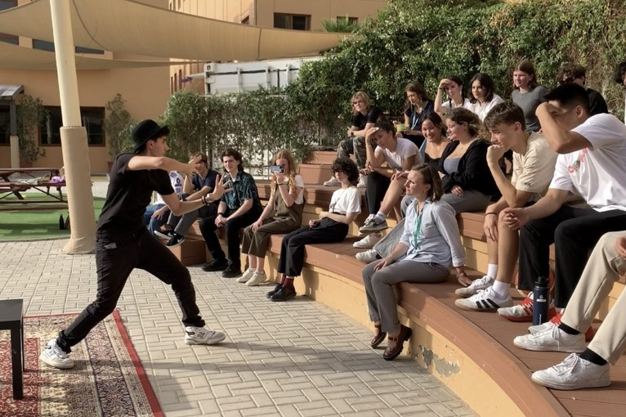
4 - Captivating performances
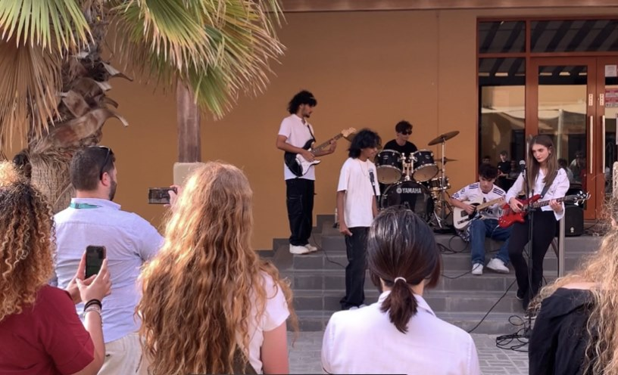
5 - Music ensable
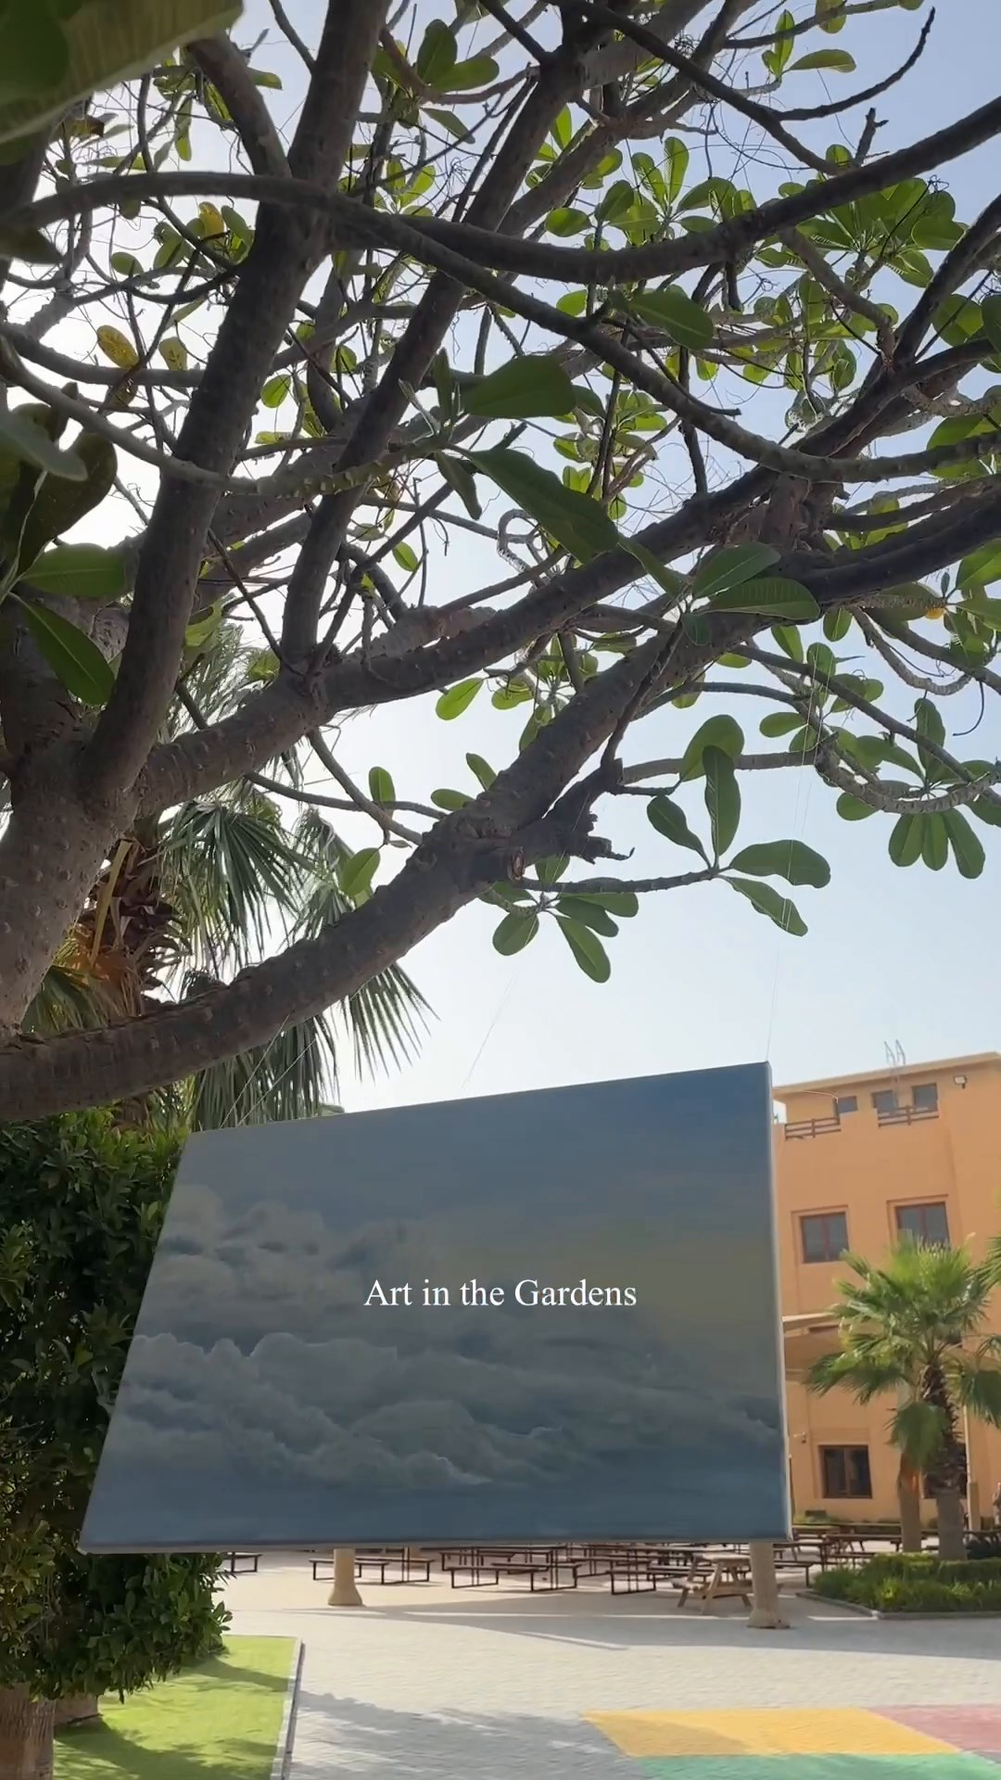
https://sway.cloud.microsoft/rQXxyDO7B4YUxZCU#content=GXe3jjnfb1CDNO
6 - https://www.instagram.com/reel/C6alehwpZQ2/?igsh=MzRlODBiNWFlZA==
Evening of the Arts
Our 2nd Evening of Arts, held on Tuesday, was a great opportunity for our DP Arts students to present their creativity and progress to a live audience of friends and family. If you missed it, view the Art on The Gardens Exhibition of artworks and enjoy the performances by our Grade 11 Visual Art, Music and Theatre Studies students:
Padlet LINK

Events This Week
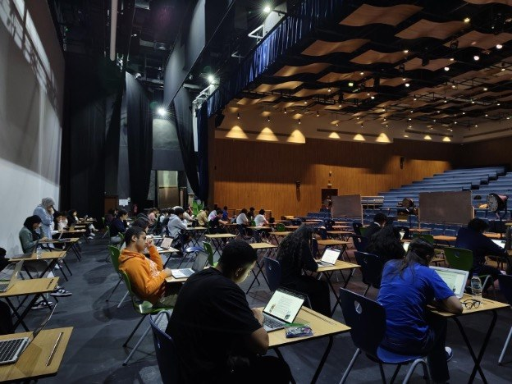
DP MoE Final Exam
بكل سعادة نعلن أن جميع طلاب الصف الثاني عشر قد أكملوا تقييماتهم الوزاريّة في مادتي اللُّغة العربية والتربية الإسلامية 🎉 نحن فخورون حقا بإنجازاتكم ونرجو لكم النجاح بأعلى الدرجات! 🌟 قسم اللغة العربية🌟
We're thrilled to share that all our Grade 12 students have completed their Ministry of Education (MoE) Arabic and Islamic assessments 🎉 Thank you to all the students for their hard work and dedication. We're proud of your achievements, we wish you success with the highest grades! 🌟
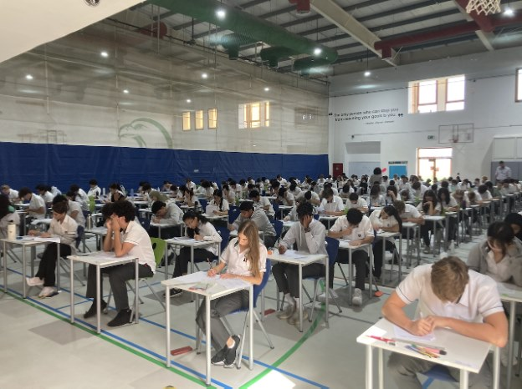
7 - Grade 10 students had their first taste of exam week!
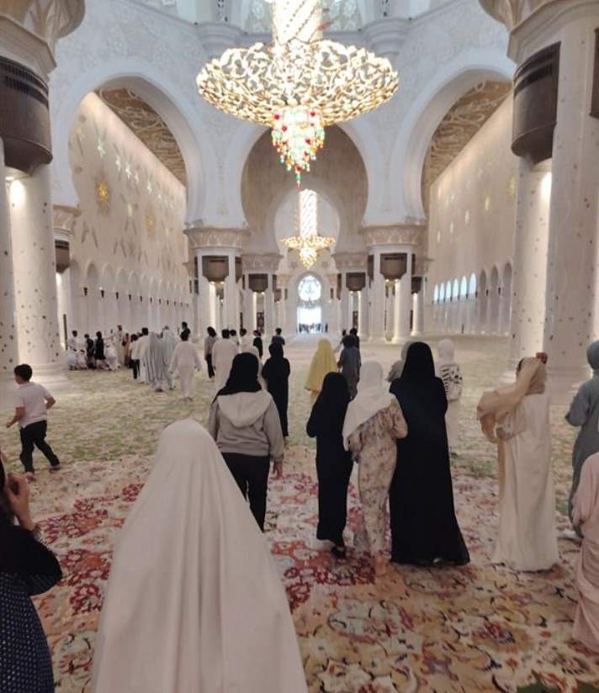
8 - Sheikh Zayed Grand Mosque Trip

Sports
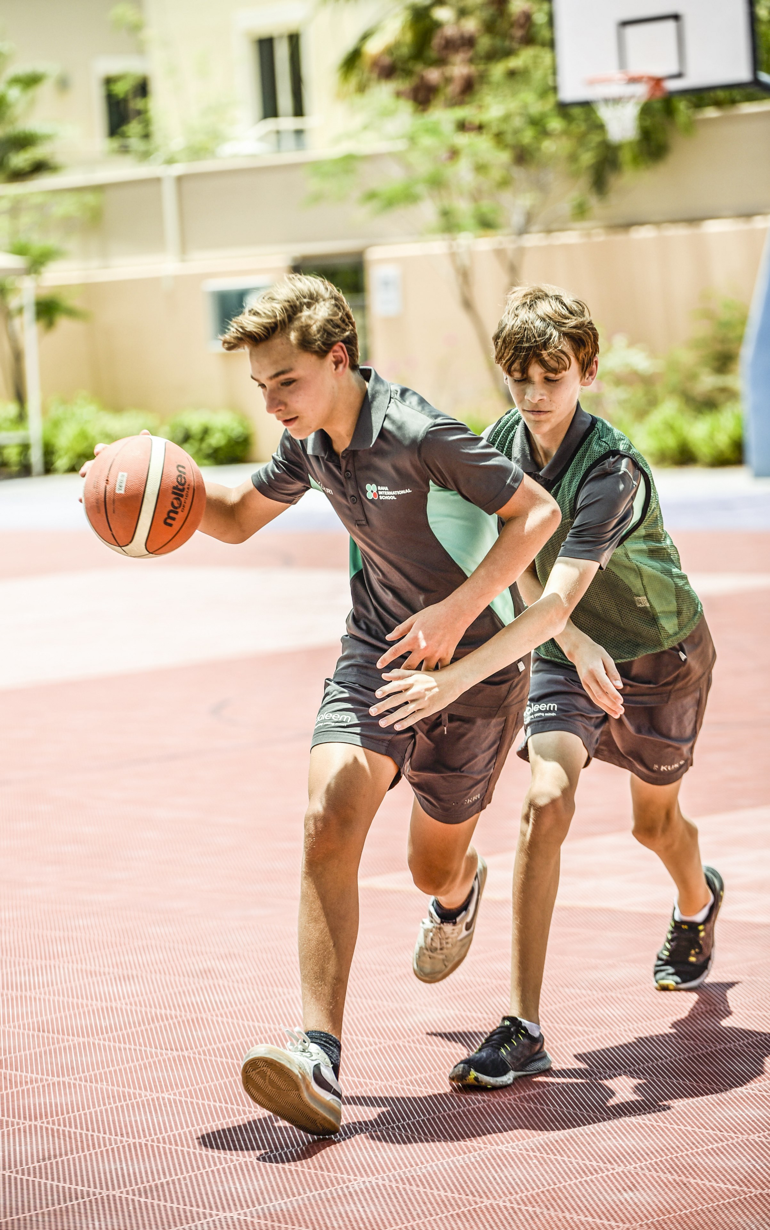
Raptor 76ers to the finals Jr NBA Championship
Our Jr NBA team has made it to the championship game again this year. We are scheduled to play for first place this weekend. Come cheer on our Raptor 76ers as they compete in the Jr NBA Championship!
5 May: NYU Abu Dhabi (gym) - 2:30 PM
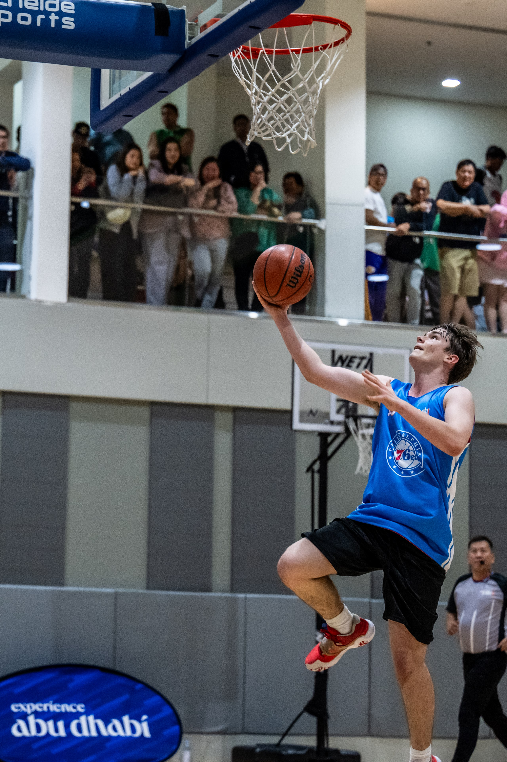
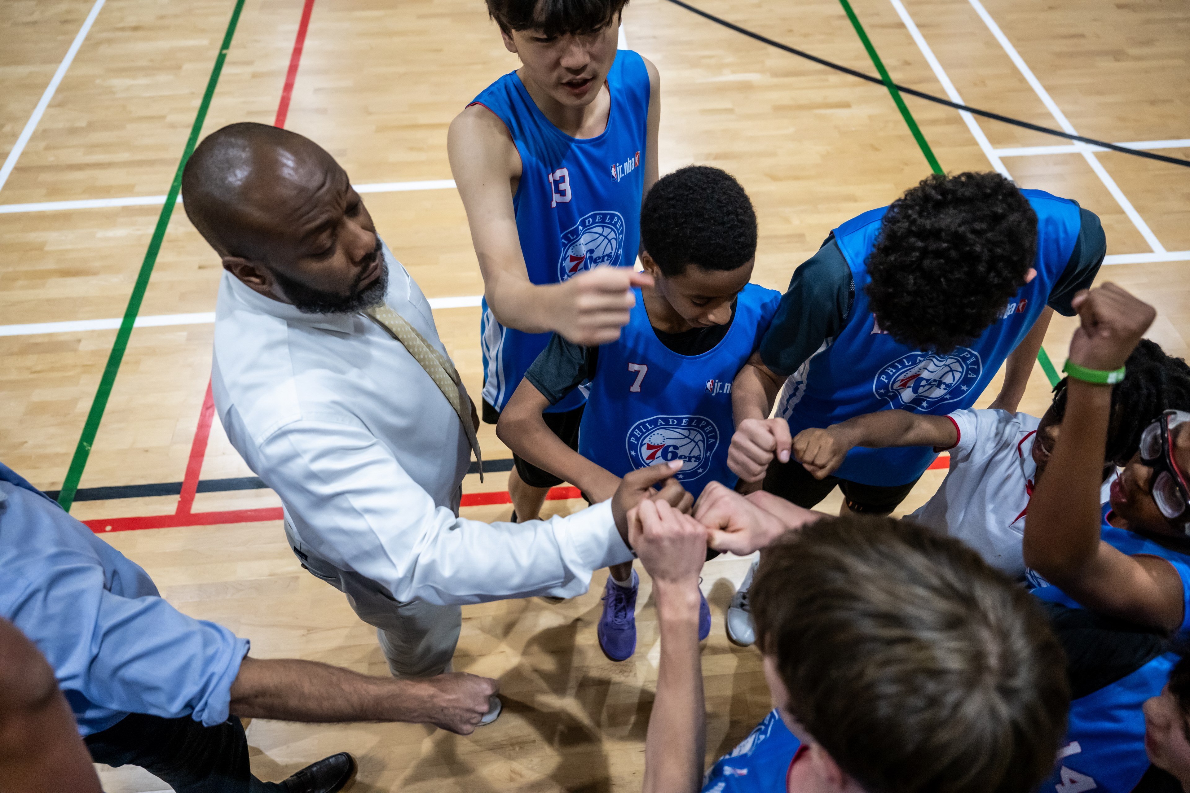
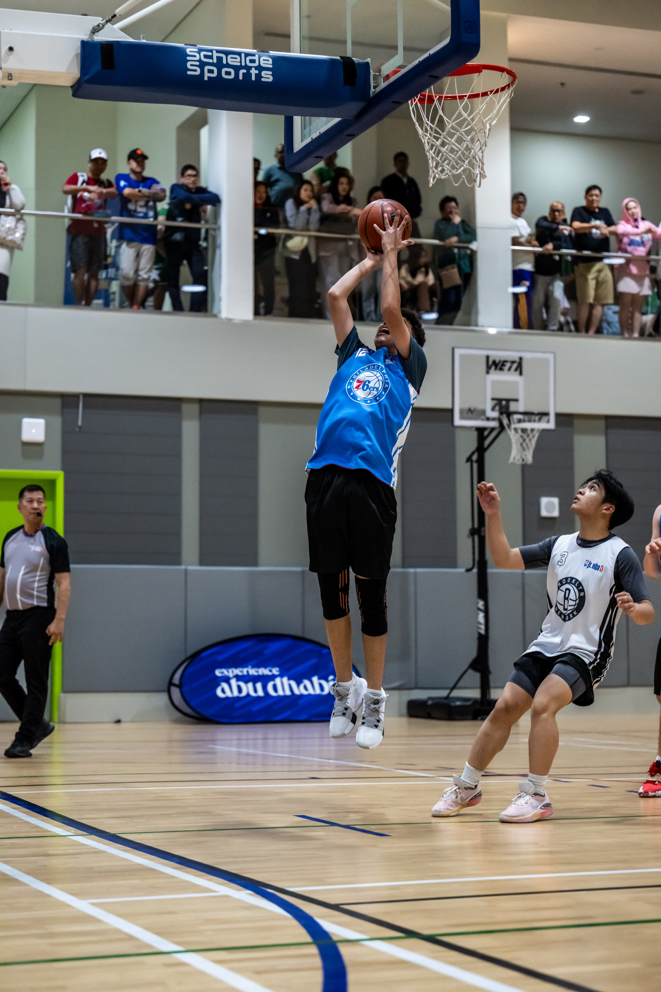

Secondary Sports Awards Evening: 21 May 5:30-7:00pm
All students who played on a Raha Raptors team this year are invited, along with their parents, to the Sports Awards Presentation. All the teams will be recognized in the Auditorium from 5:30-6:30pm on 21 May. Then, you are welcome to join the coaches in the canteen for a treat and refreshments with your fellow Raha Raptors athletes!

Primary Sports Awards Evening: 28 May 5:30-7:00pm
All students who played on a Raha Raptors team this year are invited, along with their parents, to the Primary Sports Awards Presentation. All the teams will be recognized in the Auditorium from 5:30-6:30pm on 28 May. Then, you are welcome to join the coaches in the canteen for a treat and refreshments with your fellow Raha Raptors athletes!

- 6 May: Raha Raptors Sports U13 Boys Basketball starts
- 6 May: U15 Boys Basketball Game - Maplewood
- 6 May: U15 Boys Basketball Game - Raha
- 8 May: U13 Girls Basketball Game - Raha
- 13 May: U15 Boys Basketball - Cranleigh
- 13 May: U15 Girls Basketball - Raha 4:00pm
- 15 May: U13 Girls Basketball - Raha 4:00pm
- 20 May: U15 Boys Basketball - KCC
- 20 May: U15 Girls Basketball - Raha 4:00pm
- 22 May: U13 Girls Basketball - Raha 4:00pm
- 27 May: U15 Girls Basketball - KCC
- 27 May: U15 Boys Basketball - Repton
- 29 May: U13 Girls Basketball
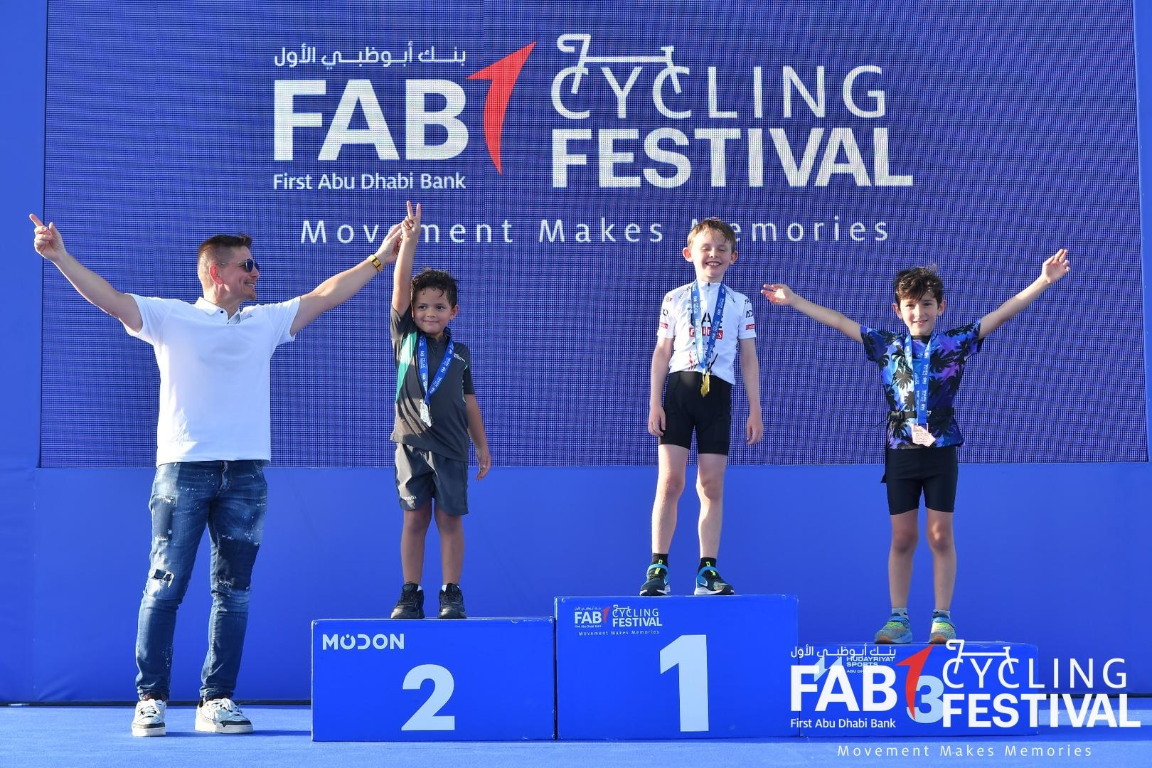
9 - Raha students podiumed during the FAB Cycling event!
